Some tricks for foldr Function

Determine the return type for the first set of dots

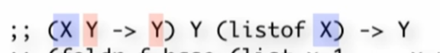

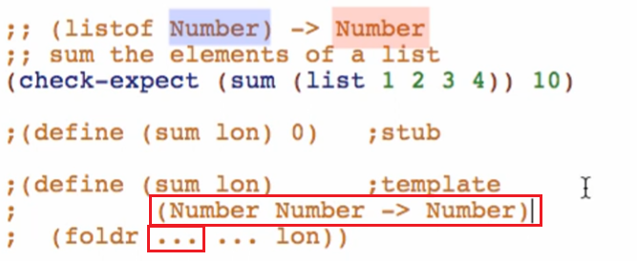

For the second set of dots





Filling in the dots

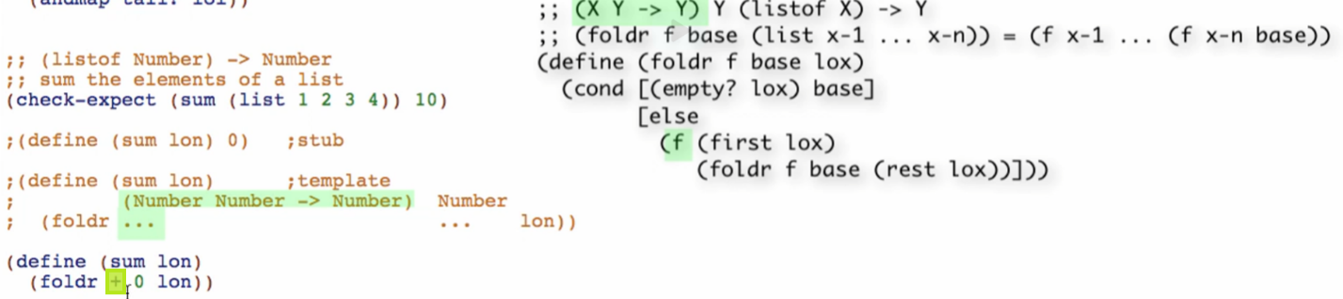

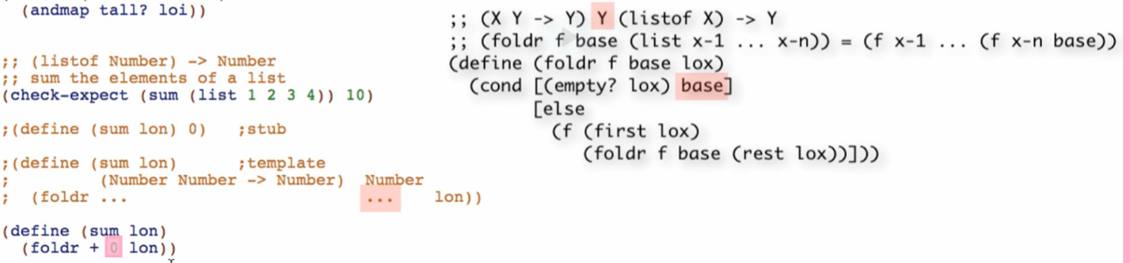

Working through the sum-to Function

1. Match the signature to the built-in functions signature

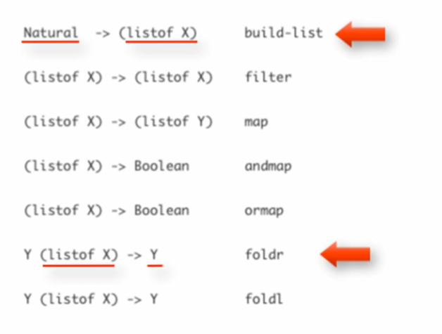

build-list first, then foldr

Sometimes one built-in function abstract list function can’t do it all. BUT we can use function composition to get what we want

1. Template foldr and build-list

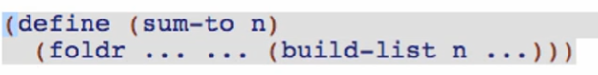

1. Fill the code body

For build-list Function

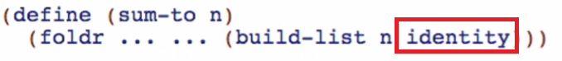

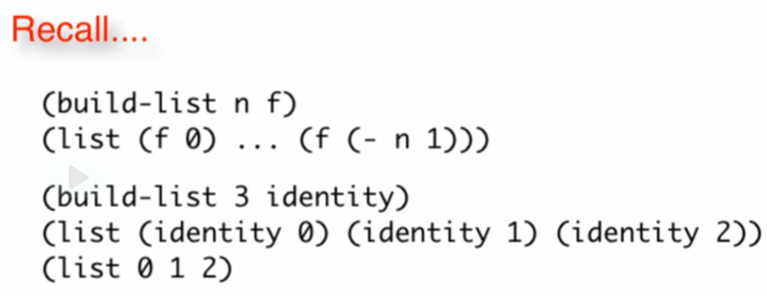

For foldr Function

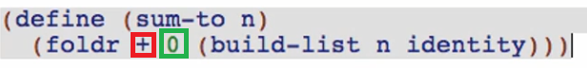

This is just like the old sum function

Overview

* First code out using ordinary list template
* Then you choose from the abstract functions
  + You don’t have to jump directly to the abstract functions

Again, do the EASIEST thing first then proceed from that 😊